PROJECT REPORTON

“Café Management System”
SRI GURU GOBIND SINGH COLLEGE
SECTOR-26, CHANDIGARH



AFFILIATED TO
PANJAB UNIVERSITY, CHANDIGARH

Submitted in partial fulfillment of the requirement for the Degree of Bachelor in Arts under
PANJAB UNIVERSITY 2024-25

SUBMITTED TO: SUBMITTED BY:
Dr..Gurpreet Kaur Sonu kumar (22104661)
Ms..Lekhika Ashish Slaria (2103363)
Sonu Bhandari (22104659)
Mohit Yadav (22104071)

BONAFIDE CERTIFICATE

Certified that this project report “Cafe Management System” is the bonafide work of
“Sonu kumar” , “Ashish Slaria”, “Sonu Bhandari” and ,“Mohit Yadav” of Bachelor of Arts 3 ^{rd} year 6th semester students of Sri Guru Gobind Singh College, Sector-26, Chandigarh carried out the project work under able supervision.

SIGNATURE
Dr..Gurpreet Kaur
HoD, PG Department of Computer Science

SIGNATURE
Ms. Lekhika

Submitted for the project viva-voce examination held on

INTERNAL EXAMINER EXTERNAL EXAMINER

ACKNOWLEDGMENT

The satisfaction and euphoria that accompany the successful completion any task would be incomplete without the mention of people whose ceaseless cooperation made it possible, whose constant guidance and encouragement crown all the efforts without our success.
I am deeply grateful to Dr.Gurpreet Kaur, HoD, PG Department of Computer Science for the guidance and support provided in the completion of this project. I am grateful to my Project Report guide Ms. Lekhika for the guidance, inspiration and constructive suggestions that helped me in the preparation of this project.
I extend our gratitude to the Principal, Professor of S.G.G.S College, Sector -26for providing us with all facilities in S.G.G.S College including college tutors staff, excellent infrastructure and an awesome environment that laid a potentially strong foundation for our professional life.

INDEX 4

S. NO | TOPIC | PAGE NO.

1 | INTRODUCTION | 5 -10
2 | FEATURE | 11-14
4 | INTRODUCTION | 15 - 16
5 | TECHNOLOGIES USED AND SYSTEM DESIGN | 17
6 | CODE -1 | 18
7 | CODE -2 | 19
8 | CODE -3 | 20 - 25
9 | CODE -4 | 25 - 32
10 | CODE -5 | 33 - 35
11 | LOGIN PAGE | 36 - 37
12 | ITEM PAGE | 38
13 | ORDER PAGE | 39
14 | ORDER LIST | 40
15 | CONCLUSION | 41
16 | REFERENCES | 42

5
VISUAL STUDIO COMMUNITY 2022

Introduction to Visual Studio Community 2022
Visual Studio Community 2022 is a free, full-featured, and powerful Integrated Development Environment (IDE) developed by Microsoft. It is designed for developers of all skill levels, including students, hobbyists, and professionals. Visual Studio provides a range of tools for developing applications across multiple platforms, including desktop, mobile, web, cloud, and more. It supports numerous programming languages such as C#, VB.Net, C++, Python, and JavaScript.
Key features of Visual Studio Community 2022 include:
- Code Editing & Debugging: Provides a highly efficient code editor with features like IntelliSense, syntax highlighting, and debugging tools.
- Support for Multiple Languages: Visual Studio allows development in various languages and frameworks, including .NET, Python, C++, JavaScript, and more.
- Git Integration: Integrated Git and Git Hub support for version control.
- Cloud and Azure Integration: Helps in building cloud-based applications and deploying them to Microsoft Azure.
- Extensibility: Supports extensions to enhance the development experience.
- Cross-Platform Development: Facilitates the creation of applications for multiple platforms like Windows, mac OS, Linux, Android, and iOS.

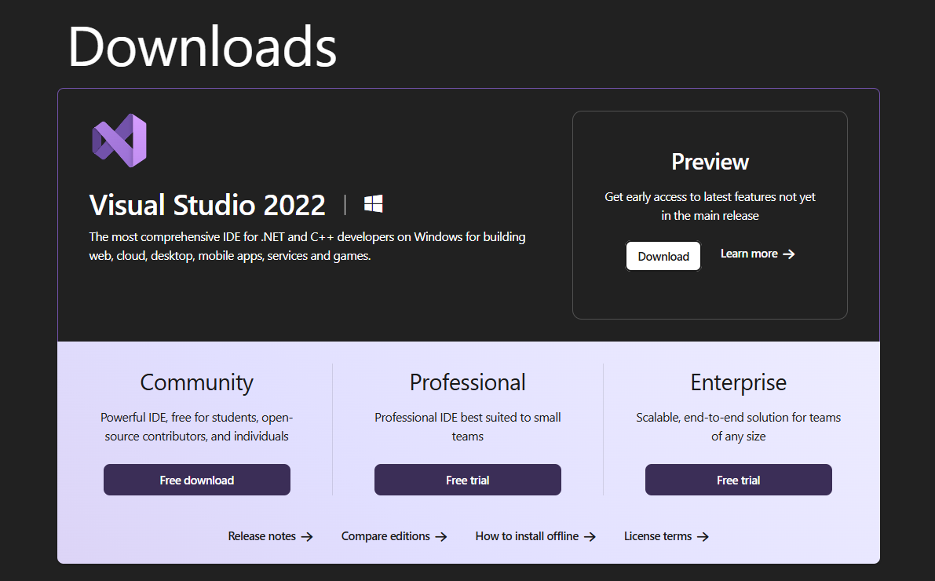

Step-by-Step Installation of Visual Studio Community 2022 6
Follow the steps below to download and install Visual Studio Community 2022.

Step 1: Download Visual Studio Community 2022
- Open your web browser and go to the official Visual Studio Download Page.
- Under the "Community" section, click on the "Download" button.



Step 2: Run the Visual Studio Installer
- After the download is complete, run the installer (you may need to grant administrator permission to proceed).
- The Visual Studio Installer window will appear.

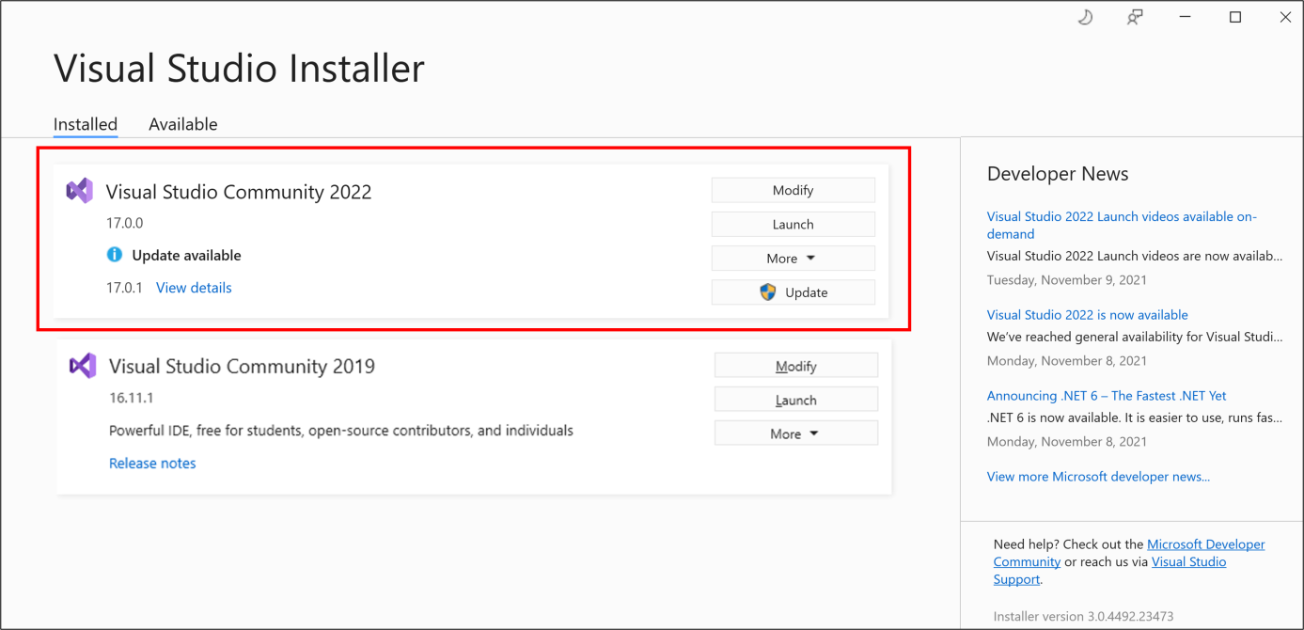
7

Step 3: Choose Workloads to Install
- In the Visual Studio Installer, you’ll be prompted to select the "workloads" or features you want to install. Workloads are collections of components and tools designed for different types of development.
  - For VB.Net or C# Development: Choose .NET Desktop Development.
  - For Web Development: Choose ASP.NET and Web Development.
  - For Mobile App Development: Choose Mobile development with .NET.
- You can also install additional features later by checking the boxes that suit your development needs.
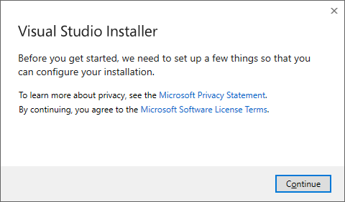

Step 4: Select Installation Location (Optional)
- If you want to change the default installation location, click on the "Installation locations" link at the bottom of the installer window.
- You can then specify the folder where you’d like Visual Studio to be installed.
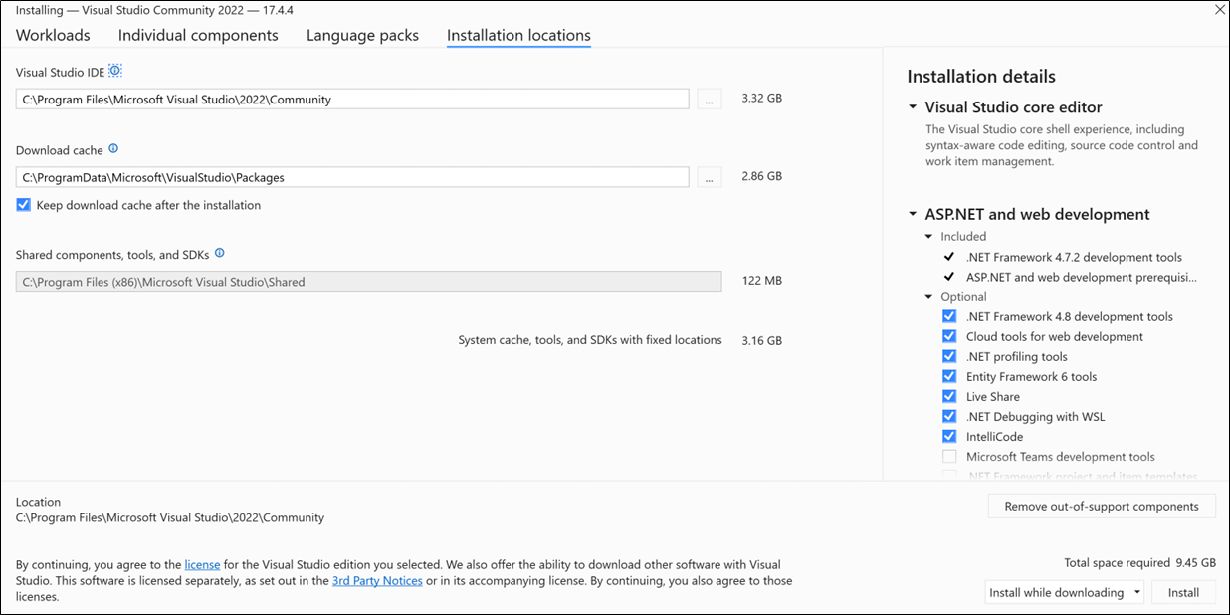

8

Step 5: Begin Installation
- After selecting your preferred workloads, click the "Install" button to begin the installation process.
- The installation may take some time depending on the selected workloads and your internet speed.

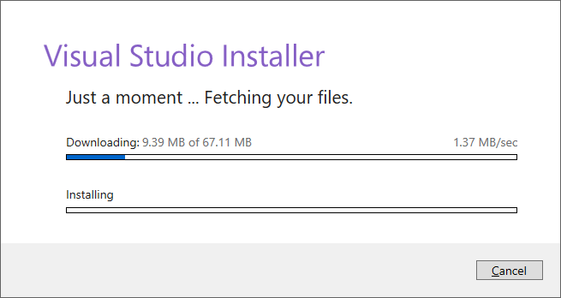

Step 6: Sign In (Optional)
- Once the installation is complete, you may be prompted to sign in with a

9

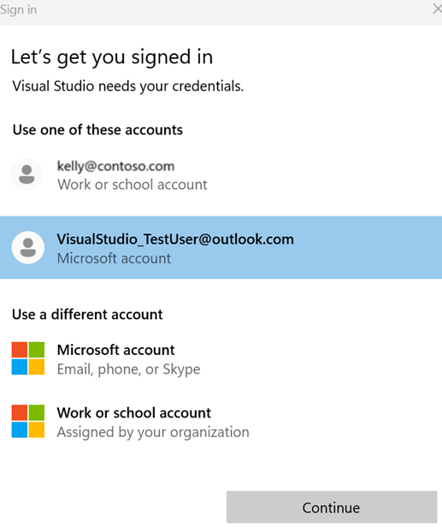

Microsoft account. Signing in is optional but offers benefits like syncing settings across devices and accessing additional features like Azure credits.

Step 7: Launch Visual Studio
- After the installation is finished, click the "Launch" button to open Visual Studio Community 2022.

- The first time you open Visual Studio, you may be asked to choose a color theme (Dark, Light, or Blue). Select your preferred theme and click "Start Visual Studio".

10

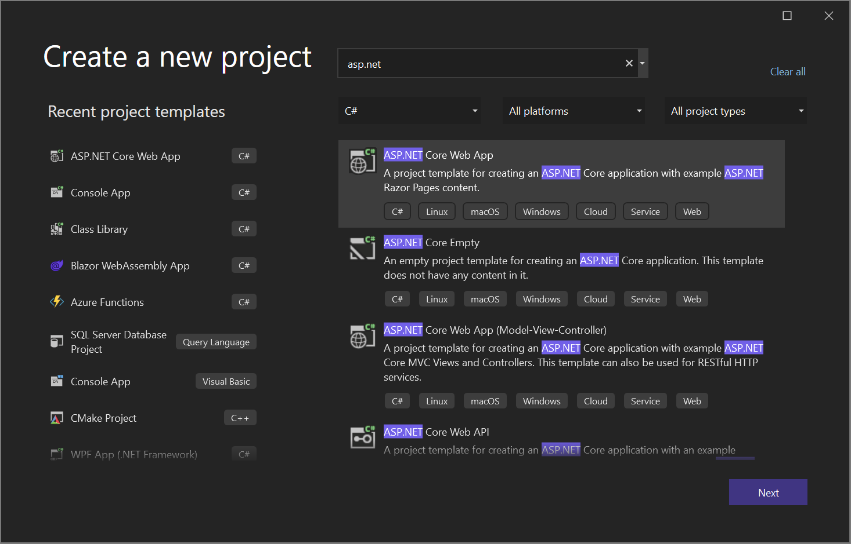

Step 8: Update Visual Studio (Optional)
Visual Studio may check for updates automatically after the installation. If updates are available, it will prompt you to install them. It’s a good idea to keep your Visual Studio installation up-to-date for the best experience and access to new features.

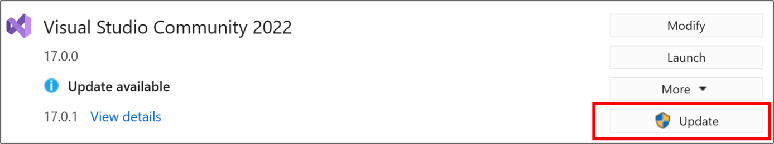

Key Features of Visual Studio Community 2022 11
Visual Studio Community 2022 is a powerful Integrated Development Environment (IDE) used for developing applications for multiple platforms. Here are some of its most prominent features:

1. Intelligent Code Editing
- IntelliSense: Offers smart code completion, parameter info, quick info, and member lists, making coding faster and more accurate.
- Syntax Highlighting: Supports multiple programming languages, such as C#, VB.Net, JavaScript, Python, and more.
- Code Snippets: Provides reusable code templates that can be inserted with shortcuts.

2. Powerful Debugging Tools
- Interactive Debugging: Debug code step-by-step, set breakpoints, inspect variables, and call stack to identify bugs in real time.
- Live Debugging: View and debug your application while it is running, both locally and remotely.
- IntelliTrace: Tracks the history of your code’s execution, helping you find and diagnose issues more easily.

3. Cross-Platform Development
- Multi-Platform Support: Develop applications for Windows, Linux, macOS, Android, and iOS all within the same IDE.
- Mobile Development: Integrate Xamarin to create cross-platform mobile apps for iOS and Android.
- Azure Integration: Easily build and deploy applications to Microsoft Azure, utilizing cloud-based services.

4. Version Control Integration
- Git & GitHub Support: Integrated Git support allows you to manage your project’s version history, track changes, and collaborate with others.
- Source Control Integration: Visual Studio integrates with Azure DevOps and Git repositories, enabling seamless version control workflows within the IDE.

5. Extensibility and Customization
- Extensions and Add-ons: Visual Studio supports a wide range of extensions from the Visual Studio Marketplace, allowing you to add custom features like additional language support, themes, and tools.
- Custom Themes: Personalize the IDE with different color themes, including Light, Dark, and Blue, to match your preferences.
- Code Refactoring: Refactor code easily by renaming variables, methods, and changing method signatures using built-in tools.

6. Rich User Interface Design
- WYSIWYG Design (What You See is What You Get): Build graphical user interfaces (GUIs) using drag-and-drop tools for Windows Forms, WPF, and UWP applications.
- XAML Designer: Visual design tool for building UWP and Xamarin mobile apps with ease.

12
- Responsive Web Design: Integrates with web design tools for building responsive websites and apps.

7. Comprehensive Testing Tools
- Unit Testing: Visual Studio includes built-in support for testing frameworks like MSTest, NUnit, and xUnit. It allows developers to write unit tests and validate their code.
- Test Explorer: View and run tests directly from within the IDE.
- Live Unit Testing: Automatically run tests while writing code, offering immediate feedback on changes.

8. Cloud Integration
- Azure Cloud Development: Easily integrate Azure resources like databases, storage, and compute services into your application.
- App Deployment: Deploy applications to the cloud with just a few clicks.

9. Database Support
- SQL Server Integration: Directly connect, manage, and interact with SQL Server databases, design queries, and work with data.
- Database Projects: Build and deploy database solutions directly within Visual Studio using SQL Server Data Tools (SSDT).
- Data Binding: Bind database results to user interface components quickly for data-driven applications.

10. Performance Tools
- Profiler: Identify and fix performance issues in your application by analyzing CPU usage, memory usage, and thread performance.
- Memory Diagnostics: Track memory usage and identify leaks and inefficiencies in your app.
- Live Metrics: View the real-time performance of your application while it runs.

11. Intelligent Code Suggestions & Refactoring
- Refactoring Tools: Automatically suggest refactorings that improve code quality, such as renaming methods or extracting methods.
- Quick Actions: Inline actions that help with code cleanup, converting methods, fixing issues, and more.

12. Integrated Command Line Interface
- Terminal Support: Use integrated terminal support for command-line tools directly inside Visual Studio. You can access PowerShell.

13. Accessibility Features
- Screen Reader Support: Full support for screen readers for developers with visual impairments.
- High Contrast Themes: Different color themes to improve accessibility for developers with various visual disabilities.

13

14. Documentation and Support
- Inline Documentation: Supports inline code documentation using XML comments for easy reference.
- Built-in Help: Includes built-in documentation for all .NET libraries and frameworks.
- Community and Support: Active community forums, official documentation, and direct support from Microsoft for troubleshooting.

15. Cloud and Containerized Development
- Docker Support: Develop containerized applications using Docker for deployment in cloud environments.
- Kubernetes Support: Integrate Kubernetes for managing containerized applications and deploying them at scale.

INTRODUCTION 15
Introduction to Café Management System in VB.Net
The Café Management System in VB.Net is a simple software that helps manage a café easily. It allows taking orders, making bills, tracking stock, and handling payments. Made with VB.Net and a database like SQL Server/MS Access, it has a user-friendly interface. This system saves time, reduces mistakes, and makes café work faster and better. Perfect for small cafés to manage daily tasks smoothly.

Key Features of the Café Management System:
- Customer Management: The system allows for the registration of new customers, storing their contact details and order history for personalized service.
- Order Management: Employees can easily input orders, modify them, and track the status of each order from preparation to serving.
- Menu Management: The system supports dynamic management of the menu, where new items can be added, prices can be adjusted, and special offers or discounts can be applied.
- Inventory Management: Real-time tracking of ingredients and supplies ensures that the café always has what it needs to serve customers without overstocking.
- Billing and Payment: The system automatically generates bills based on customer orders, calculates totals (including taxes), and provides multiple payment options.
- Reports: It offers various reports, including sales analysis, inventory reports, and daily transactions, helping owners and managers track business performance.

Benefits of the System:
- Efficiency: The automation of order taking, billing, and inventory management significantly reduces the time spent on manual tasks, leading to faster service and fewer mistakes.
- Accuracy: Reduces human error in calculations, billing, and stock tracking.
- Inventory Control: Helps in tracking inventory levels in real time, ensuring there are no shortages or waste.
- Improved Customer Service: Faster order processing and a better overall customer experience.
16
Business Insights: Reporting tools allow café managers to make data-driven decisions, optimizing operations and profitability.

Technologies Used:
- Visual Basic .NET (VB.Net15): A powerful programming language for developing Windows applications.
- Microsoft Access / SQL Server: For database management, storing customer data, order details, and inventory information.
- Windows Forms: Provides a graphical user interface (GUI) that is easy to use and navigate for café staff.
The Café Management System aims to improve the overall efficiency of café operations and contribute to a better customer experience. By automating key processes, café owners can focus on growing their business rather than managing day-to-day operations manually.

TECHNOLOGIES USED AND SYSTEM DESIGN 17

Technologies Used in VB.Net and SQL System Design
- VB.Net (Visual Basic .NET):
  - A modern, object-oriented programming language for building Windows applications.
  - Used for creating the application’s frontend (UI), business logic, and handling events.
  - Supports integration with the .NET framework for advanced features like security, database connectivity, and file handling.
- SQL (Structured Query Language):
  - A language used to manage and query relational databases.
  - SQL commands like SELECT, INSERT, UPDATE, and DELETE are used for interacting with data in databases.
  - Ensures data integrity, consistency, and security within relational databases.
- ADO.NET (Active Data Objects for .NET):
  - A data access technology for connecting VB.Net applications to SQL databases.
  - Facilitates execution of SQL queries, retrieval of data, and updates to the database.
  - Works with database providers such as SQL Server to manage database connections and commands.
- SQL Server (or other RDBMS):
  - Relational Database Management System (RDBMS) used to store and manage the application's data.
  - Examples include Microsoft SQL Server, MySQL, or SQLite.

System Design (VB.Net and SQL)
- Frontend (VB.Net Application):
  - UI Development: Using Windows Forms or WPF for creating the user interface.
  - Event-Driven Programming: Responds to user actions like button clicks, form submissions, etc.
- Backend (SQL Database):
  - Database Design: Tables for storing data (e.g., Users, Orders), with primary and foreign keys to establish relationships.
  - SQL Queries: Used to retrieve, insert, update, and delete data in the database.
  - Stored Procedures: Encapsulate SQL logic in the database for reusable operations.
- Communication:
  - ADO.NET: Facilitates communication between VB.Net and SQL database, executing queries and fetching results.
  - Data Access Layer: Handles data transactions between the application and the database.

CODE SNIPPETS 18

Splash Page Code
Public Class Form1
Private Sub imgClose_Click(sender As Object, e As EventArgs) Handles imgClose.Click
Application.Exit()
End Sub
Private Sub Timer1_Tick(sender As Object, e As EventArgs) Handles Timer1.Tick
ProgressBar1.Increment(1)
If ProgressBar1.Value = 100 Then
Me.Hide()
Dim log = New Login
log.Show()
Timer1.Enabled = False
End If
End Sub
Private Sub Form1_Load(sender As Object, e As EventArgs) Handles MyBase.Load
Timer1.Start()
End Sub
End Class

Login Page Code 19
Public Class Login
Private Sub imgClose_Click(sender As Object, e As EventArgs) Handles imgClose.Click
Application.Exit()
End Sub
Private Sub btnLogin_Click(sender As Object, e As EventArgs) Handles btnLogin.Click
If txtUsername.Text = "" Or txtPassword.Text = "" Then
MsgBox("Enter Username and Password")
ElseIf txtUsername.Text = "Admin" And txtPassword.Text = "Password" Then
Dim Obj = New Items
Obj.Show()
Me.Hide()
Else
MsgBox("You have entered wrong Username or Password")
txtUsername.Text = ""
txtPassword.Text = ""
End If
End Sub
Private Sub btnSeller_LinkClicked(sender As Object, e As LinkLabelLinkClickedEventArgs) Handles btnSeller.LinkClicked
Dim Obj = New Order
Obj.Show()
M
e.Hide()
End Sub
End Class
Items Page Code 20
Imports System.Data.SqlClient
Public Class Items
Dim Con = New SqlConnection(“Data Source=(LocalDB)\MSSQLLocalDB;AttachDbFilename=C:\Full Projects\UI Cafe Management System\UI Cafe Management System\UIDB.mdf;Integrated Security=True”)
Private Sub imgClose_Click(sender As Object, e As EventArgs) Handles imgClose.Click
Application.Exit()
End Sub
Private Sub btnSeller_Click(sender As Object, e As EventArgs) Handles btnSeller.Click
Dim Obj = New Order
Obj.Show()
Me.Hide()
End Sub
Private Sub btnLogout_Click(sender As Object, e As EventArgs) Handles btnLogout.Click
Dim Obj = New Login
Obj.Show()
Me.Hide()
End Sub
Private Sub imgLogout_Click(sender As Object, e As EventArgs) Handles imgLogout.Click
Dim Obj = New Login
Obj.Show()
Me.Hide()
End Sub

Private Sub imgSeller_Click(sender As Object, e As EventArgs) Handles imgSeller.Click
21
Dim Obj = New Order
Obj.Show()
Me.Hide()
End Sub
Private Sub Reset()
txtItemname.Text = ""
CbCategory.SelectedIndex = 0
txtItemPrice.Text = ""
txtItemQnty.Text = ""
End Sub
Private Sub FillCategory()
Con.Open()
Dim cmd = New SqlCommand("select * from CategoryTbl", Con)
Dim adapter = New SqlDataAdapter(cmd)
Dim Tbl = New DataTable()
adapter.Fill(Tbl)
CbCategory.DataSource = Tbl
CbCategory.DisplayMember = "CategoryName"
CbCategory.ValueMember = "CategoryName"
Con.Close()
End Sub
Private Sub btnAddCategory_Click(sender As Object, e As EventArgs) Handles btnAddCategory.Click
22
If txtCategory.Text = "" Then
MsgBox("Enter Category Name")
Else
Con.Open()
Dim query = "insert into CategoryTbl values('" & txtCategory.Text & "')"
Dim cmd As SqlCommand
cmd = New SqlCommand(query, Con)
cmd.ExecuteNonQuery()
MsgBox("Category Added")
Con.Close()
txtCategory.Text = ""
FillCategory()
End If
End Sub
Private Sub DisplayItems()
Con.Open()
Dim query = "select * from ItemsTbl"
Dim cmd = New SqlCommand(query, Con)
Dim adapter = New SqlDataAdapter(cmd)
Dim builder = New SqlCommandBuilder(adapter)
builder = New SqlCommandBuilder(adapter)
Dim ds = New DataSet()
adapter.Fill(ds)
23
DGVItems.DataSource = ds.Tables(0)
Con.Close()
End Sub
Private Sub btnAdd_Click(sender As Object, e As EventArgs) Handles btnAdd.Click
If txtItemname.Text = "" Or CbCategory.SelectedIndex = -1 Or txtItemPrice.Text = "" Or txtItemQnty.Text = "" Then
MsgBox("Missing Information!")
Else
Con.Open()
Dim query = "insert into ItemsTbl values('" & txtItemname.Text & "','" & CbCategory.SelectedValue.ToString() & "','" & txtItemPrice.Text & "'," & txtItemQnty.Text & ")"
Dim cmd As SqlCommand
cmd = New SqlCommand(query, Con)
cmd.ExecuteNonQuery()
MsgBox("Item Added")
Con.Close()
Reset()
DisplayItems()
End If
End Sub
Private Sub btnUpdate_Click(sender As Object, e As EventArgs) Handles btnUpdate.Click
If txtItemname.Text = "" Or CbCategory.SelectedIndex = -1 Or txtItemPrice.Text = "" Or txtItemQnty.Text = "" Then
24
MsgBox("Missing Information!")
Else
Try
Con.Open()
Dim query = "update ItemsTbl set ItemName='" & txtItemname.Text & "',ItemCategory='" & CbCategory.SelectedValue.ToString() & "',ItemPrice=" & txtItemPrice.Text & ", ItemQnty=" & txtItemQnty.Text & " where ItemId=" & Key & ""
Dim cmd As SqlCommand
cmd = New SqlCommand(query, Con)
cmd.ExecuteNonQuery()
MsgBox("Item Updated")
Con.Close()
Reset()
DisplayItems()
Catch ex As Exception
MsgBox(ex.Message)
End Try
End If
End Sub
Private Sub btnDelete_Click(sender As Object, e As EventArgs) Handles btnDelete.Click
If Key = 0 Then
MsgBox("Select Details to Delete!")
Else
Con.Open()
Dim query = "delete from ItemsTbl where ItemId=" & Key & "" 24
Dim cmd As SqlCommand
cmd = New SqlCommand(query, Con)
cmd.ExecuteNonQuery()
MsgBox("Item Deleted")
Con.Close()
Reset()
DisplayItems()
End If
End Sub
Private Sub btnReset_Click(sender As Object, e As EventArgs) Handles btnReset.Click
Reset()
End Sub
Dim Key = 0
Private Sub DGVItems_CellContentClick(sender As Object, e As DataGridViewCellEventArgs) Handles DGVItems.CellContentClick
Dim row As DataGridViewRow = DGVItems.Rows(e.RowIndex)
txtItemname.Text = row.Cells(1).Value.ToString
CbCategory.SelectedValue = row.Cells(2).Value.ToString
txtItemPrice.Text = row.Cells(3).Value.ToString
txtItemQnty.Text = row.Cells(4).Value.ToString
If txtItemname.Text = "" Then
Key = 0
Else
Key = Convert.ToInt32(row.Cells(0).Value.ToString) 25
End If
End Sub
Private Sub Items_Load(sender As Object, e As EventArgs) Handles MyBase.Load
FillCategory()
DisplayItems()
End Sub
End Class
Billing Page Code
Imports System.Data.SqlClient
Public Class Order
Dim Con = New SqlConnection(“Data Source=(LocalDB)\MSSQLLocalDB;AttachDbFilename=C:\Full Projects\UI Cafe Management System\UI Cafe Management System\UIDB.mdf;Integrated Security=True”)
Private Sub imgClose_Click(sender As Object, e As EventArgs) Handles imgClose.Click
Application.Exit()
End Sub
Private Sub btnItems_Click(sender As Object, e As EventArgs) Handles btnItems.Click
Dim Obj = New Login
Obj.Show()
Me.Hide()
End Sub Private Sub imgItem_Click(sender As Object, e As EventArgs) Handles imgItem.Click
Dim Obj = New Login
Obj.Show()
Me.Hide() 26
End Sub
Private Sub btnLogout_Click(sender As Object, e As EventArgs) Handles btnLogout.Click
Dim Obj = New Login
Obj.Show()
Me.Hide()
End Sub
Private Sub imgLogout_Click(sender As Object, e As EventArgs) Handles imgLogout.Click
Dim Obj = New Login
Obj.Show()
Me.Hide()
End Sub
Private Sub Label9_Click(sender As Object, e As EventArgs) Handles Label9.Click
Dim Obj = New View_Orders
Obj.Show()
Me.Hide()
End Sub
Private Sub DisplayItems()
Con.Open()
Dim query = "select * from ItemsTbl"
Dim cmd = New SqlCommand(query, Con)
Dim adapter = New SqlDataAdapter(cmd)
Dim builder = New SqlCommandBuilder(adapter)
builder = New SqlCommandBuilder(adapter) 27
Dim ds = New DataSet()
adapter.Fill(ds)
DGVItems.DataSource = ds.Tables(0)
Con.Close()
End Sub
Private Sub btnRefresh_Click(sender As Object, e As EventArgs) Handles btnRefresh.Click
DisplayItems()
End Sub
Private Sub FilterByCategory()
Con.Open()
Dim query = "select * from ItemsTbl where ItemCategory='" & CbCategory.SelectedValue.ToString() & "'"
Dim cmd = New SqlCommand(query, Con)
Dim adapter = New SqlDataAdapter(cmd)
Dim builder = New SqlCommandBuilder(adapter)
builder = New SqlCommandBuilder(adapter)
Dim ds = New DataSet()
adapter.Fill(ds)
DGVItems.DataSource = ds.Tables(0)
Con.Close()
End Sub
Private Sub FillCategory()
Con.Open()
Dim cmd = New SqlCommand("select * from CategoryTbl", Con) 28
Dim adapter = New SqlDataAdapter(cmd)
Dim Tbl = New DataTable()
adapter.Fill(Tbl)
CbCategory.DataSource = Tbl
CbCategory.DisplayMember = "CategoryName"
CbCategory.ValueMember = "CategoryName"
Con.Close()
End Sub
Private Sub CbCategory_SelectionChangeCommitted(sender As Object, e As EventArgs) Handles CbCategory.SelectionChangeCommitted
FilterByCategory()
End Sub

Private Sub Order_Load(sender As Object, e As EventArgs) Handles MyBase.Load
FillCategory()
DisplayItems()
End Sub
Dim ProdName As String
Dim i = 0, GrandTotal = 0, Price, Qnty
Private Sub UpdateItem()
Try
Dim NewQnty = Stock - Convert.ToInt32(txtItemQnty.Text)
Con.Open()
Dim query = "update ItemsTbl set ItemQnty=" & NewQnty & " where ItemId=" 29
& Key & "
Dim cmd As SqlCommand
cmd = New SqlCommand(query, Con)
cmd.ExecuteNonQuery()
MsgBox("Item Updated")
Con.Close()
DisplayItems()
Catch ex As Exception
MsgBox(ex.Message)
End Try
End Sub
Private Sub btnAddtoBill_Click(sender As Object, e As EventArgs) Handles btnAddtoBill.Click
If Key = 0 Then
MsgBox("Select an Item")
ElseIf Convert.ToInt32(txtItemQnty.Text) > Stock Then
MsgBox("No Enough Stock")
Else
Dim rnum As Integer = DGVBills.Rows.Add()
Dim total = Convert.ToInt32(txtItemQnty.Text) * Price
i = i + 1
DGVBills.Rows.Item(rnum).Cells("Column1").Value = i
DGVBills.Rows.Item(rnum).Cells("Column2").Value = ProdName
DGVBills.Rows.Item(rnum).Cells("Column3").Value = Price 30
DGVBills.Rows.Item(rnum).Cells("Column4").Value = txtItemQnty.Text
DGVBills.Rows.Item(rnum).Cells("Column5").Value = total
GrandTotal = GrandTotal + total
LblTotal.Text = "Rs " + Convert.ToString(GrandTotal)
UpdateItem()
txtItemQnty.Text = ""
Key = 0
End If
End Sub
Dim Key = 0, Stock
Private Sub DGVItems_CellContentClick(sender As Object, e As DataGridViewCellEventArgs) Handles DGVItems.CellContentClick
Dim row As DataGridViewRow = DGVItems.Rows(e.RowIndex)
ProdName = row.Cells(1).Value.ToString
If ProdName = "" Then
Key = 0
Stock = 0
Else
Key = Convert.ToInt32(row.Cells(0).Value.ToString)
Stock = Convert.ToInt32(row.Cells(4).Value.ToString)
Price = Convert.ToInt32(row.Cells(3).Value.ToString)
End If
End Sub
Private Sub PrintDocument_PrintPage(sender As Object, e As 31
Printing.PrintPageEventArgs) Handles PrintDocument.PrintPage
e.Graphics.DrawString("Cafe Shop", New Font("Arial", 22), Brushes.BlueViolet, 335, 35)
e.Graphics.DrawString("***YourBill***", New Font("Arial", 14), Brushes.BlueViolet, 350, 60)
Dim bm As New Bitmap(Me.DGVBills.Width, Me.DGVBills.Height)
DGVBills.DrawToBitmap(bm, New Rectangle(0, 0, Me.DGVBills.Width, Me.DGVBills.Height))
e.Graphics.DrawImage(bm, 0, 90)
e.Graphics.DrawString("Total Amount " + GrandTotal.ToString(), New Font("Arial", 15), Brushes.Crimson, 325, 580)
e.Graphics.DrawString("************** Thanks for Buying in Our Cafe ****************", New Font("Arial", 15), Brushes.Crimson, 130, 600)
End Sub
Private Sub AddBill()
Con.Open()
Dim query = "insert into OrdersTbl values('" & DateTime.Today.Date & "'," & GrandTotal & ")"
Dim cmd As SqlCommand
cmd = New SqlCommand(query, Con)
cmd.ExecuteNonQuery()
MsgBox("Bill Added")
Con.Close()
End Sub
Private Sub Label6_Click(sender As Object, e As EventArgs) Handles Label6.Click
AddBill()
PrintPreviewDialog.Show() 32
End Sub
End Class

33

View Orders
Imports System.Data.SqlClient
Public Class View_Orders
Dim Con = New SqlConnection(“Data Source=(LocalDB)\MSSQLLocalDB;AttachDbFilename=C:\Full Projects\UI Cafe Management System\UI Cafe Management System\UIDB.mdf;Integrated Security=True”)
Private Sub imgLogout_Click(sender As Object, e As EventArgs) Handles imgLogout.Click
Dim Obj = New Login
Obj.Show()
Me.Hide()
End Sub
Private Sub btnLogout_Click(sender As Object, e As EventArgs) Handles btnLogout.Click
Dim Obj = New Login
Obj.Show()
Me.Hide()
End Sub
Private Sub btnItems_Click(sender As Object, e As EventArgs) Handles btnItems.Click
Dim Obj = New Login
Obj.Show()
Me.Hide()
End Sub
Private Sub imgItem_Click(sender As Object, e As EventArgs) Handles imgItem.Click
Dim Obj = New Login
Obj.Show()
Me.Hide()
End Sub
34
Private Sub btnBack_Click(sender As Object, e As EventArgs) Handles btnBack.Click
Dim Obj = New Order
Obj.Show()
Me.Hide()
End Sub
Private Sub imgClose_Click(sender As Object, e As EventArgs) Handles imgClose.Click
Application.Exit()
End Sub
Private Sub DisplayBills()
Con.Open()
Dim query = "select * from OrdersTbl"
Dim cmd = New SqlCommand(query, Con)
Dim adapter = New SqlDataAdapter(cmd)
Dim builder = New SqlCommandBuilder(adapter)
builder = New SqlCommandBuilder(adapter)
Dim ds = New DataSet()
adapter.Fill(ds)
DGVOrderList.DataSource = ds.Tables(0)
Con.Close()
End Sub
Private Sub View_Orders_Load(sender As Object, e As EventArgs) Handles MyBase.Load
DisplayBills()
35

End Sub
End Class

37
LOGIN PAGE

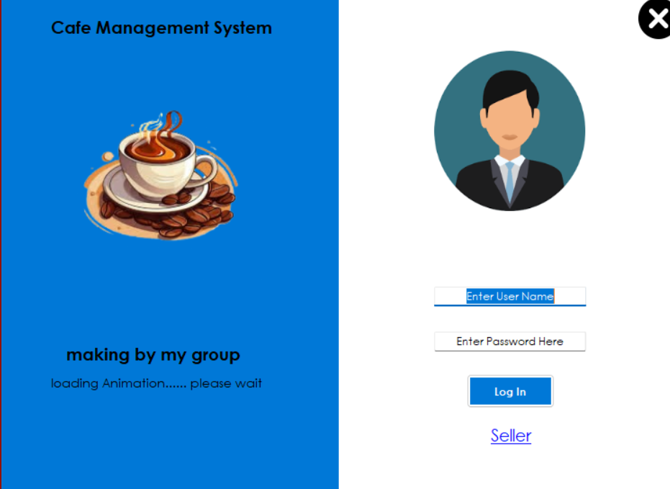

38
ITEM

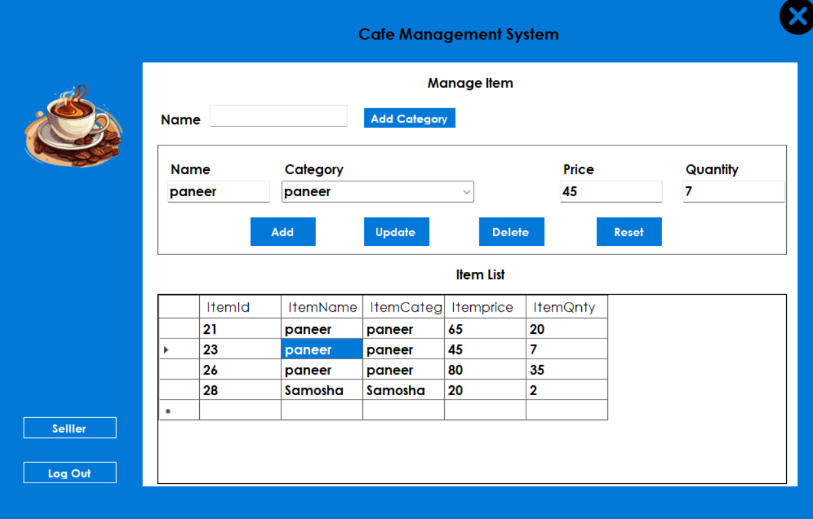

39
ORDER

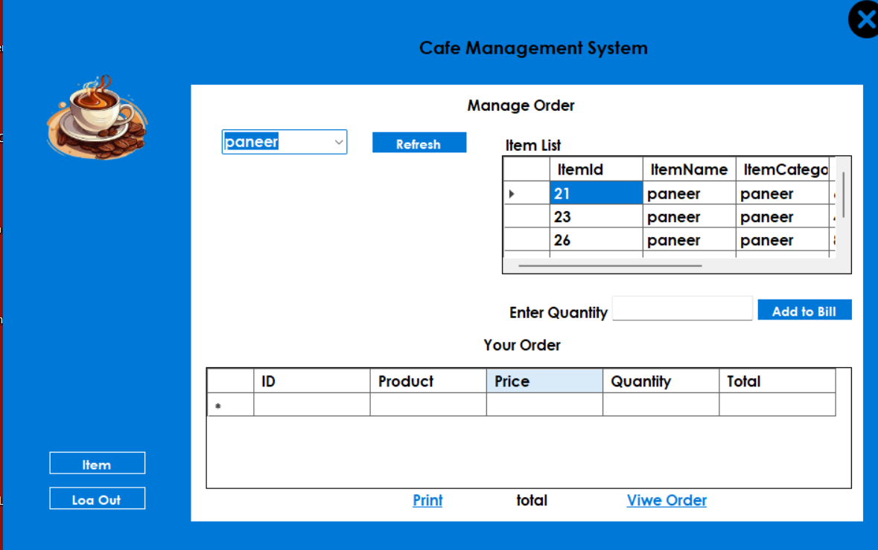

40
ORDER LIST

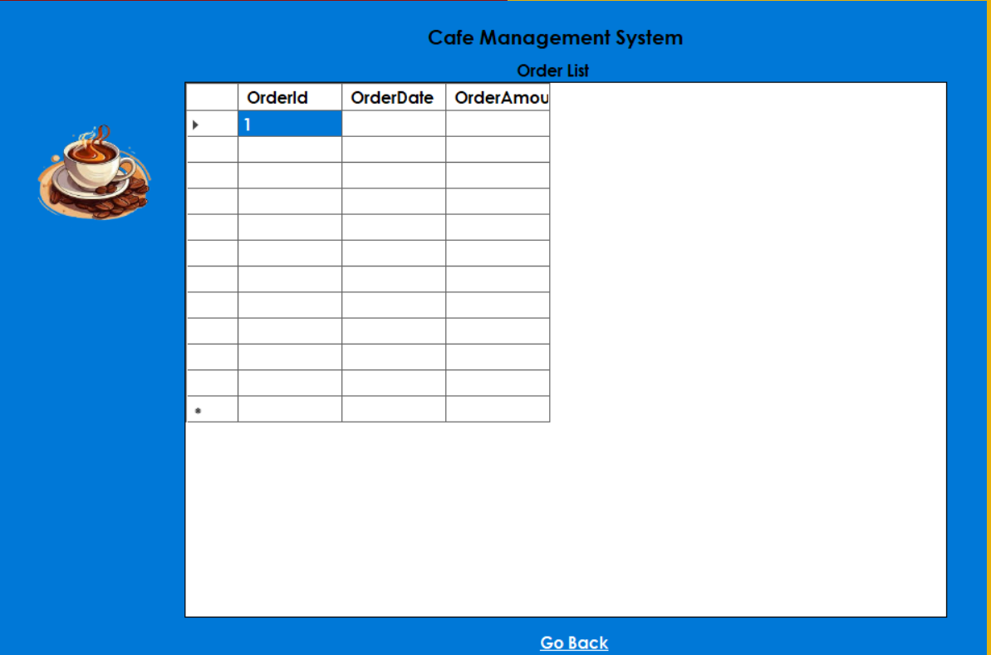

41

CONCULSION:
The Café ManagemAent System in VB.Net is a powerful and efficient tool designed to simplify and streamline the daily operations of a café. This system helps in handling essential tasks like taking orders, generating bills, tracking inventory, and managing payments, making café management more organized and hassle-free.
One of the biggest advantages of this system is its user-friendly interface, which ensures that even non-technical staff can operate it without difficulty. The system is built using VB.Net as the programming language and uses a database like SQL Server or MS Access to store all essential data, such as orders, sales, and stock details. This structured approach helps in reducing errors, improving efficiency, and speeding up service.

Key Benefits of the Café Management System:
- Easy Order Management: Staff can quickly take orders and process them without confusion.
- Automated Billing System: It calculates the total amount, applies discounts, and generates receipts instantly.
- Inventory Tracking: The system monitors stock levels and notifies when ingredients are running low.
- Fast Payment Processing: Customers can pay using cash, cards, or digital payment methods, ensuring a smooth transaction.
- Better Customer Service: Reduces waiting time and enhances customer experience.
The automation provided by the Café Management System significantly reduces manual workload, minimizes calculation errors, and prevents inventory mismanagement. This results in higher productivity, improved service speed, and better business control.
Another great feature of this system is data security. Since all data is stored in a structured database, café owners can easily access sales reports, track daily earnings, and analyze business growth over time. This helps in making better financial and operational decisions.

Final Thoughts
In conclusion, the Café Management System in VB.Net is a must-have for small and medium-sized cafés looking to improve their workflow. It helps in saving time, reducing costs, and increasing customer satisfaction. With its simple interface and effective features, this system makes café management more organized, efficient, and profitable.
By implementing this system, café owners can focus more on delivering quality service rather than handling complex manual operations. It is a smart and reliable solution that enhances overall business performance.

42
REFERENCES

Website & Online Sources

Project - https://youtu.be/UN_R8bpnDCY?si=H53meLSCpV8dsQFU

Software & Tools Used

MySql Server ,Version 8.0. Retrieved from - https://dev.mysql.com/downloads/mysql/8.0.html

Microsoft Visual Studio 2022 - https://visualstudio.microsoft.com/vs/

